Exercise 6 – Implementing the Proxy Pattern

Scenario
Develop an image viewer that uses lazy loading and caching through the Proxy Pattern.

Understanding the Proxy Pattern
The Proxy Pattern provides a placeholder object to control access to another object. It is commonly used for lazy initialization, caching, and access control.

Project Name
ProxyPatternExample

Implementation
interface Image{
void display();
}
class RealImage implements Image{
private String fileName;
RealImage(String fileName){
this.fileName=fileName;
System.out.println("Loading image from remote server...");
}
public void display(){
System.out.println("Displaying image...");
}
}
class ProxyImage implements Image{
private RealImage realImage;
private String fileName;
ProxyImage(String fileName){
this.fileName=fileName;
}
public void display(){
if(realImage==null){
realImage=new RealImage(fileName);
}
realImage.display();
}
}
public class ProxyTest{
public static void main(String[] args){
Image image=new ProxyImage("photo.jpg");
image.display();
image.display();
System.out.println("\nDisplaying cached image...");
System.out.println("\nProxy Pattern executed successfully.");
}
}

Sample Output
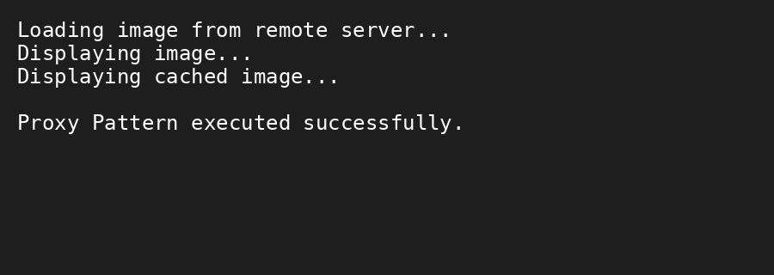

Conclusion
The Proxy Pattern delays object creation until it is required and reuses the loaded object, improving performance.

